**2**

**Biological Classification**

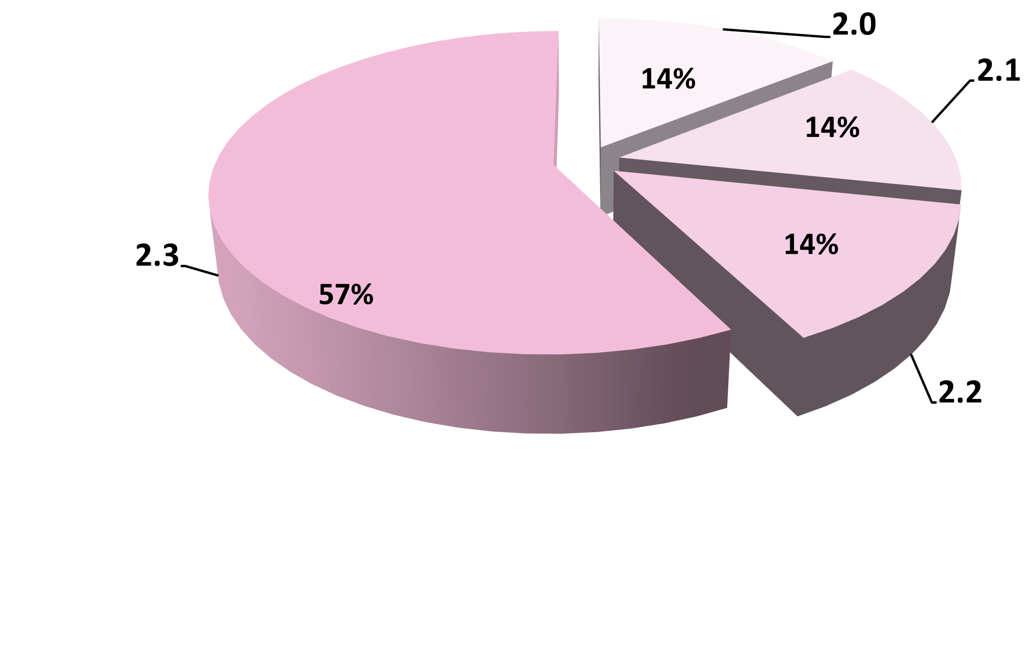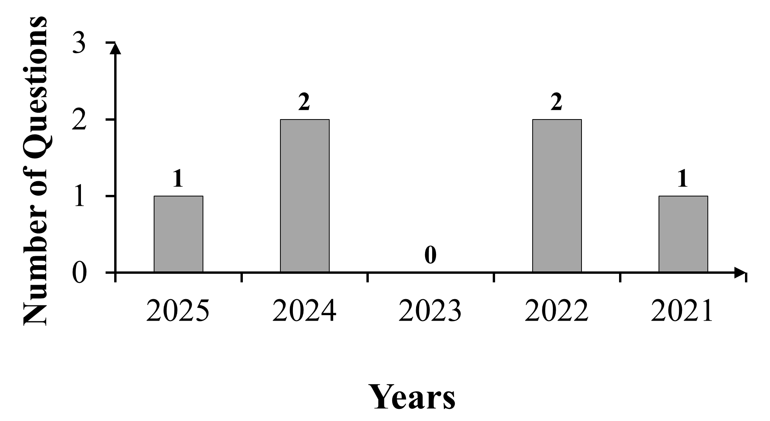

No. of Questions Asked in Previous Years

NEET(UG) Topic Trends

**NEET (UG) Past 5 Years Analysis (2021-2025)**

**Chapter Outline**

**2.4** Kingdom Plantae

**2.5** Kingdom Animalia

**2.6** Viruses, Viroids , Prions and Lichens

**2.0** Introduction

**2.1** Kingdom Monera

**2.2** Kingdom Protista

**2.3** Kingdom Fungi

**Synopsis**

**2.0 Introduction**

**⏩ Evolution of Biological Classification Systems:**

|  |  |  |
| --- | --- | --- |
| **Scientist** | **Key Contribution** | **Classification System** |
| **Aristotle** | Classified plants as trees, shrubs, herbs based on growth form; animals based on presence/absence of red blood. | Early Morphological Classification |
| **Carolus**  **Linnaeus** | Introduced binomial nomenclature and classified all organisms into two kingdoms. | Two Kingdoms  (Plantae and Animalia) |
| **Ernst Haeckel** | Introduced a third kingdom – Protista, primarily for unicellular eukaryotes and some simple multicellular organisms. | Three Kingdoms  (Protista, Plantae and Animalia) |
| **Herbert F. Copeland** | Proposed **four kingdoms**; created **Kingdom Monera** for bacteria and cyanobacteria. | Four Kingdoms  (Monera, Protista, Plantae and Animalia) |
| **R.H.**  **Whittaker** | Proposed a five-kingdom system based on cellular structure, body organisation level, mode of nutrition, reproduction and phylogenetic relationships. | Five Kingdoms  (Monera, Protista, Fungi, Plantae and Animalia) |
| **Carl**  **Woese** | Proposed the **Three Domain System**, dividing prokaryotes into Archaea and Bacteria, leading to six kingdoms under three domains. | Three Domains & Six Kingdoms  (Eubacteria, Archaebacteria, Protista, Fungi, Plantae and Animalia) |

**⏩ Characteristics of the Five Kingdoms:**

|  |  |  |  |  |  |
| --- | --- | --- | --- | --- | --- |
|  | **Five Kingdoms** | | | | |
| **Monera** | **Protista** | **Fungi** | **Plantae** | **Animalia** |
| **Cell Type** | Prokaryotic | Eukaryotic | Eukaryotic | Eukaryotic | Eukaryotic |
| **Cell Wall** | - Non-cellulosic  (e.g., peptidoglycan in bacteria).  - Cell wall absent in some organisms  (e.g., Mycoplasma). | Present in some | Present  (with chitin) | Present (cellulose) | Absent |
| **Nuclear Membrane** | Absent | Present | Present | Present | Present |
| **Body Organisation** | Cellular | Cellular | Mostly multicellular (filamentous hyphae) or unicellular (e.g., yeasts). | Tissue / organ | Tissue / organ /  organ system |
| **Mode of Nutrition** | Autotrophic (chemosynthetic or photosynthetic) or heterotrophic (saprophytic or parasitic). | Autotrophic (photosynthetic and heterotrophic) | Heterotrophic (saprophytic /  parasitic) | Autotrophic (photosynthetic); some are partially heterotrophic (e.g., insectivorous plants) | Heterotrophic (holozoic,  saprophytic, etc.) |

**Need for a classification system:**

Imagine navigating a supermarket where items lack labels or organisation, making specific products hard to locate. Finding salt would take forever!

i. Classification in biology functions like shelf labels in a store—it organizes organisms into meaningful groups based on shared characteristics.

ii. Without classification, studying or identifying organisms would be chaotic, as researchers would lack a framework to distinguish species or infer relationships.

**Analogy**



**2.1 Kingdom Monera**

**i. Organisms included:** Bacteria

**ii. Classification of bacteria based on their shape:**

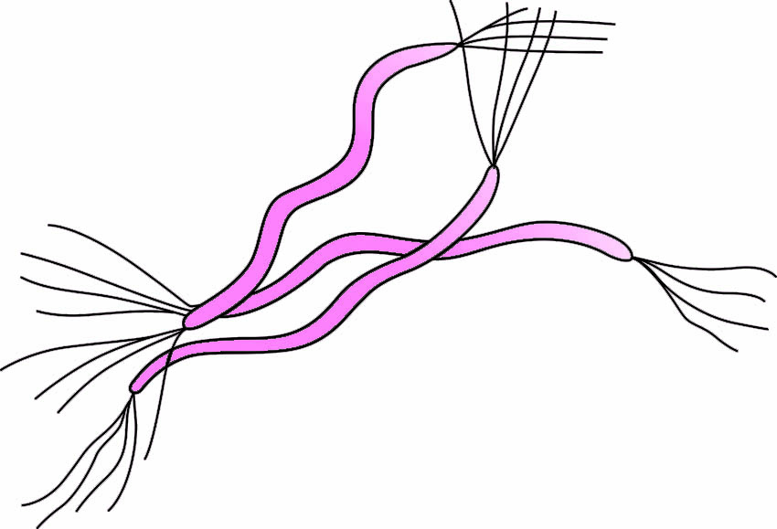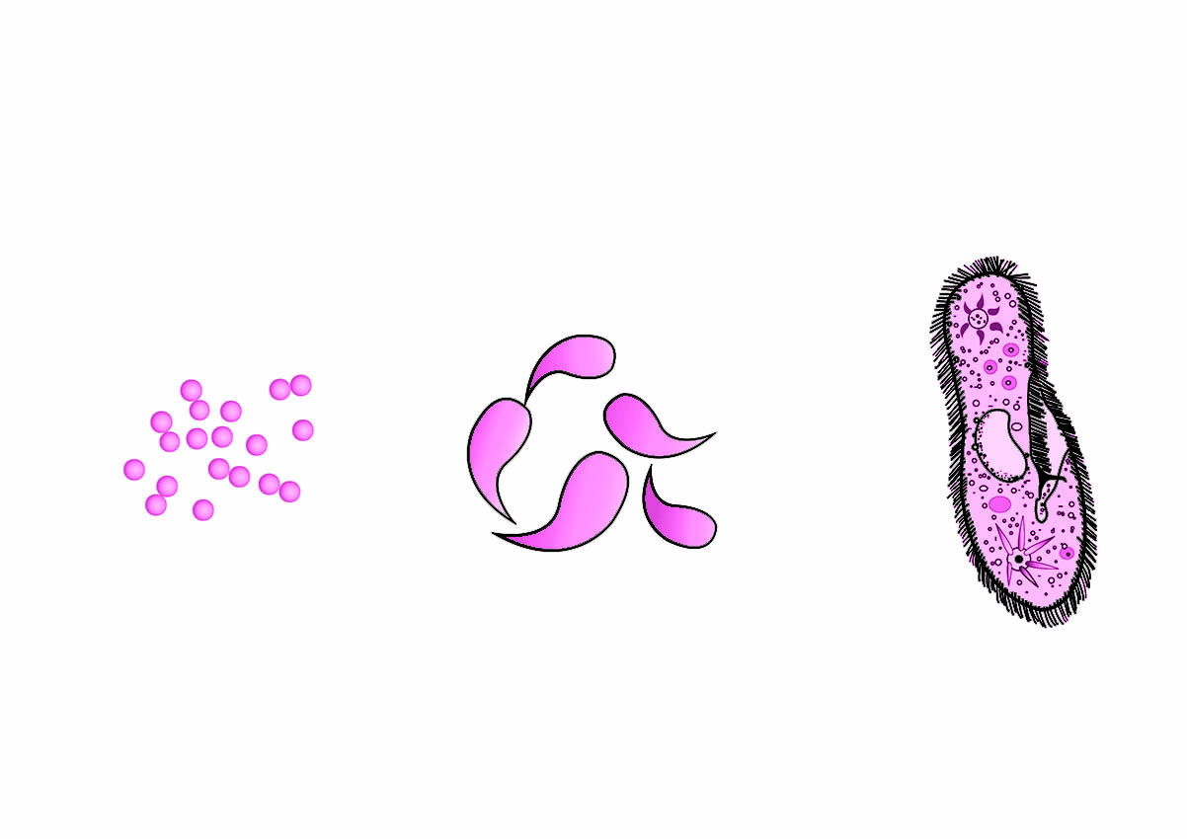

**Bacteria of different shapes**

**Cocci**

(Spherical)

**Bacilli**

(Rod shaped)

**Spirilla**

(Spiral)

**Vibrio**

(Comma shaped)

Spore

Flagellum

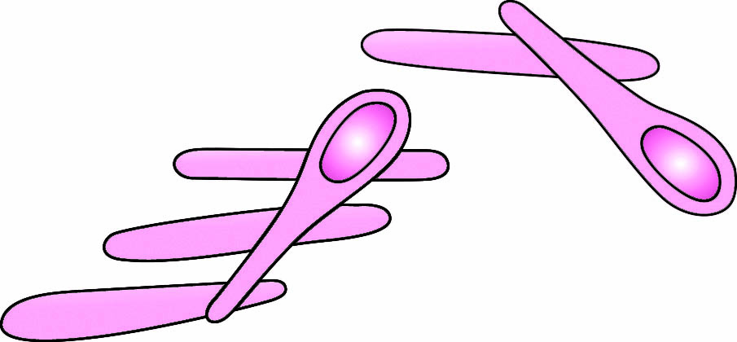

• Survive in extreme conditions

• Cell wall is made up of pseudopeptidoglycan (pseudomurein).

**Archaebacteria**

• Obligate anaerobes

• Found in marshy areas

• Present in gut of several ruminants (cows and buffaloes)

• Responsible for production of methane.

**Methanogens**

• Include cyanobacteria, also called blue-green algae and anoxygenic types of bacteria.

• Presence of chlorophyll a

• Unicellular, colonial or filamentous

• Freshwater/ marine/ terrestrial algae

• Colonies surrounded by gelatinous sheath

• Some of them can fix atmospheric nitrogen in specialised cells called heterocysts. E.g., *Nostoc*, *Anabaena*

**Photosynthetic bacteria**

**Kingdom Monera**

• True bacteria

• They show presence of a rigid cell wall and flagellum (if motile).

• Cell wall is made up of peptidoglycan.

**Eubacteria**

• Live in extreme salty areas

**Halophiles**

• Found in hot springs

• Able to tolerate high temperature as well as high acidity

**Thermoacidophiles**

• Oxidise various inorganic substances such as nitrates (NO3), nitrites (NO2) and ammonia (NH3) and synthesize organic compounds.

• They use the released energy for ATP production.

• They play a major role in recycling nutrients like nitrogen, phosphorus, iron and sulphur.

• Most abundant in nature.

• Majority are decomposers.

• They are helpful in making curd from milk, production of antibiotics, fixing of nitrogen in legume roots, etc.

• Some are pathogenic; may cause diseases like cholera, typhoid, tetanus, citrus canker, etc.

**Heterotrophic bacteria**

**Chemosynthetic bacteria**

**⏩ Mycoplasma:**

i. They are among the smallest known living cells.

ii. They lack a cell wall.

iii. They can survive in the absence of oxygen.

iv. Many are pathogenic.

**Mycoplasma: The Jokers of the Microbial World**

Imagine a joker in a card game-He doesn't follow the rules and can fit in wherever needed.

i. Mycoplasma are similar rule-breakers – they lack a cell wall, which makes them flexible and resistant to cell wall-targeting antibiotics like penicillin.

ii. Just as jokers surprise opponents, Mycoplasma can be pathogenic – causing diseases like pneumonia despite their minimal size.

**Analogy**



**2.2 Kingdom Protista**

i. They are mostly aquatic.

ii. They possess a well-defined nucleus and other membrane-bound organelles.

iii. Some possess flagella, cilia, or pseudopodia for locomotion.

iv. Depending on the group Protists reproduce asexually (e.g., binary fission, spore formation) or sexually through processes like cell fusion and zygote formation.

v. **Members are further divided into groups:**

|  |  |  |  |  |  |
| --- | --- | --- | --- | --- | --- |
| **Feature** | **Chrysophytes** | **Dinoflagellates** | **Euglenoids** | **Slime moulds** | **Protozoans** |
| **Habitat** | Freshwater and marine | Mostly marine | Freshwater (stagnant water) | Moist decaying organic matter | Aquatic, moist soil, or parasitic |
| **Mode of Nutrition** | Primarily autotrophic (photosynthetic), some heterotrophic or mixotrophic | Primarily autotrophic (photosynthetic), some heterotrophic or mixotrophic | Mixotrophic (photosynthetic in light, heterotrophic in darkness) | Saprophytic | Heterotrophic (predatory, parasitic, or saprophytic) |
| **Cell Wall / Membrane** | Silica-impregnated wall (soap box-like) | Cellulose plates on cell surface | No wall; flexible protein layer (*pellicle*) | Plasma membrane only | Plasma membrane present; no rigid wall |
| **Flagella** | Absent | Two (one longitudinal, one transverse) | Two (one long, one short) | Absent | May be present (in some groups like flagellates) |
| **Locomotion** | Passive (float in water currents) | Active (via flagella) | Active (via flagella) | Amoeboid movement of plasmodium | Pseudopodia / flagella / cilia / non-motile |
| **Reproduction** | Mainly asexual | Mostly asexual | Primarily  Asexual | Asexual (spore formation in fruiting bodies) | Asexual and sexual reproduction |
| **Other Features** | Indestructible walls form diatomaceous earth (used in filtration, polishing) | Cause red tides;  Some release toxins | Contain pigments similar to higher plants (e.g., chlorophyll) | Form *plasmodium* which spreads & later forms spores | Divided into 4 groups: Amoeboid, Flagellated, Ciliated, Sporozoans |
| **Examples** | *Diatoms*, *Desmids* | *Gonyaulax* | *Euglena* | *Physarum* | *Amoeba*, *Trypanosoma*, *Paramecium*, *Plasmodium* |

**Dual Mode of Nutrition in Euglenoids:**

Imagine a hybrid car that runs on both electricity and petrol, depending on the situation.

i. Euglenoids can photosynthesize in sunlight (like electricity use).

ii. In darkness, they switch to ingesting food (like using petrol).

iii. This adaptability is why they are considered both autotrophic and heterotrophic.

**Analogy**



vi. **Groups of Protozoans:**

|  |  |  |
| --- | --- | --- |
| **Groups** | **Characteristics** | **Examples** |
| **Amoeboid Protozoans** | Live in freshwater, seawater, and moist soil. They move and capture prey using pseudopodia. Some marine forms have silica shells. | *Amoeba*, *Entamoeba* |
| **Flagellated Protozoans** | Either free-living or parasitic. Some cause diseases such as sleeping sickness. | *Trypanosoma* |
| **Ciliated Protozoans** | Aquatic, show presence of many cilia. They possess an oral groove/cytostome for feeding. Ciliates have two different types of nuclei: micronucleus and a macronucleus. | *Paramecium* |
| **Sporozoans** | They exhibit an infectious, spore-like stage in their life cycle, often as parasites. | *Plasmodium* (malarial parasite) |

i. Plasmodium of Slime moulds: A multinucleate blob of protoplasm without cell walls.

ii. *Plasmodium* (Protozoan) : Malarial parasites

**CAUTION**



**2.3 Kingdom Fungi**

1. **General characteristics:**

|  |  |  |
| --- | --- | --- |
| **Feature** |  | **Details** |
| **Nature** | → | Eukaryotic, non-motile heterotrophic organisms |
| **Habitat** | → | Fungi are cosmopolitan, found in air, water, soil, decaying matter, and on plants and animals, thriving in warm and humid conditions. |
| **Nutrition** | → | Saprophytic/ parasitic, or symbiotic (e.g., lichens – with algae; mycorrhiza – with plant roots) |
| **Structure** | → | Fungi may be unicellular (e.g., yeasts) or filamentous, with hyphae forming a mycelium; their cell walls contain chitin and other polysaccharides. |
| **Hyphae Types** | → | Coenocytic or septate |
| **Reproduction** | → | **Vegetative** – Fragmentation, fission, budding **Asexual** – Zoospores, sporangiospores, conidia **Sexual** – Oospores, ascospores, basidiospores |
| **Sexual Cycle Stages** | → | 1. Plasmogamy → 2. Karyogamy → 3. Meiosis |
| **Dikaryon Stage** | → | Seen in *Ascomycetes* and *Basidiomycetes* (n + n stage before diploid formation) |
| **Fruiting Bodies** | → | Specialized reproductive structures where spores are produced and released. |

**ii. During sexual reproduction:**

a. In some fungi, the fusion of two haploid cells results in diploid cells (2n).

b. In Ascomycetes and Basidiomycetes, an intermediate dikaryotic stage (n + n) occurs, where each cell contains two unfused haploid nuclei (dikaryon).

c. Subsequently, the parental nuclei fuse (karyogamy), forming diploid cells, followed by meiosis in the fruiting bodies, producing haploid spores.

1. **Various groups of fungi:**

|  |  |  |  |  |
| --- | --- | --- | --- | --- |
| **Feature** | **Phycomycetes** | **Ascomycetes** | **Basidiomycetes** | **Deuteromycetes** |
| **Common Name** | Algal fungi | Sac fungi | Club fungi | Fungi Imperfecti |
| **Habitat** | Aquatic, damp decaying matter, or obligate parasites on plants | Terrestrial – decomposers, growing on dung (coprophilous), parasites | Soil, wood, living plants (parasitic forms) | Mostly terrestrial – saprophytes, parasites, decomposers |
| **Mycelium** | Aseptate, coenocytic | Septate, branched | Septate, branched | Septate, branched |
| **Asexual Reproduction** | Zoospores (motile) or Aplanospores (non-motile) in sporangia | By conidia (exogenously on conidiophores) | Usually absent; vegetative reproduction by fragmentation | Only by conidia |
| **Sexual Reproduction** | Fusion of gametes → zygospore (isogamy, anisogamy, oogamy) | Fusion of gametes → ascospores in asci | Fusion of somatic cells → basidiospores on basidium | Sexual reproduction unknown or unconfirmed |
| **Sexual Spores** | Zygospore | Ascospores (endogenously formed in asci) | Basidiospores (exogenously formed on basidium) | Absent |
| **Fruiting Body** | Not well-defined | Ascocarp | Basidiocarp | Absent |
| **Examples** | *Mucor*, *Rhizopus*, *Albugo* | *Aspergillus*, *Penicillium*, *Neurospora*, *Yeast*, *Claviceps* | *Agaricus*, *Puccinia*, *Ustilago* | *Alternaria*, *Colletotrichum*, *Trichoderma* |
| **Other Features** | Spores produced endogenously in sporangium | Mostly multicellular (rarely unicellular, e.g., yeast like *Saccharomyces*).  Conidia germinate directly into mycelium; includes edible fungi (morels, truffles). | Sexual organs absent; prolonged dikaryotic stage; basidiospores formed externally on basidia. | Members often reclassified into Ascomycetes or Basidiomycetes once sexual forms are known.  Most of them are decomposers. |

Deuteromycetes include fungi for which only vegetative or asexual phases are known. Once their sexual forms are discovered, members of this group are reclassified into their respective classes.

**CAUTION**



**Smart tip**

Out of the four main fungal groups, **only Phycomycetes** have **aseptate, coenocytic hyphae**, while Ascomycetes, Basidiomycetes, and Deuteromycetes possess **septate hyphae.**



**2.4 Kingdom Plantae**

i. Plants are multicellular, eukaryotic, chlorophyll-containing organisms capable of photosynthesis.

(A few members are partially heterotrophic, e.g. Bladderwort and Venus flytrap are insectivorous plants, *Cuscuta* is a parasite.)

ii. Their cells have chloroplasts and a cell wall composed of cellulose.

iii. The plant life cycle features two alternating phases: the diploid sporophytic phase and the haploid gametophytic phase, a phenomenon known as alternation of generations.

iv. Kingdom Plantae includes various groups—algae, bryophytes, pteridophytes, gymnosperms, and angiosperms.

All algae are not classified under Plantae; in the five-kingdom system of classification they occur in **Monera** (blue-green algae/cyanobacteria: *Nostoc, Anabaena*), **Protista** (diatoms, *Euglena*), and **Plantae** (green/brown/red algae: *Chlamydomonas, Spirogyra; Sargassum; Gelidium, Gracilaria*).

**CAUTION**



**Connections**

*In chapter 3 Plant Kingdom, you will study the classification of kingdom Plantae in detail.*



**2.5 Kingdom Animalia**

i. They are heterotrophic, eukaryotic organisms.

ii. They are multicellular and lack cell walls.

iii. Most of the members digest food in an internal cavity (e.g., stomach) and store energy reserves as glycogen or fat.

iv. Mode of nutrition is typically holozoic

v. Reproduction mostly sexual; fertilisation internal/external; development direct/indirect.

vi. Higher forms exhibit elaborate sensory and neuromotor mechanisms.

**Connections**

*In chapter 4 Animal Kingdom, you will study the classification of Kingdom Animalia in detail.*



**2.6** **Viruses, Viroids, Prions and Lichens**

**1. Viruses:**

● **Structure:** Acellular, form inert crystalline structures outside a host; have a protein coat called capsid.

● **Genetic Material:** Either DNA or RNA as their primary genetic material (never both)

● **Discovery:** Dmitri Ivanovsky (1892) who identified filterable agents causing tobacco mosaic disease.

● **Naming & Concept:** M.W. Beijerinck (1898) coined 'virus' (Latin for poisonous fluid) and termed it *Contagium vivum fluidum* (contagious living fluid).

● **Crystallisation Proof:** W.M. Stanley (1935) showed viruses can be crystallised, with crystals consisting largely of proteins.

● **Nature:** Obligate parasites; replicate only inside host cells

● **Shapes of Capsid:** Helical or polyhedral (constructed from protein subunits called capsomeres)

● **Examples of Diseases caused bwy viruses:** AIDS, Influenza, Herpes, Mumps, Smallpox, Tobacco Mosaic Disease

● **Symptoms of viral disease in plants:** Mosaic formation, leaf rolling, curling, dwarfing, stunted growth

**Virus and host cell:**

Think of a virus as a USB drive loaded with a dangerous program—it’s inert on its own. Plug it into a computer (the host), and it takes over. This mirrors how viruses behave—lifeless outside a host, aggressive once inside.

**Analogy**



**2. Viroids**

● **Structure:** Naked RNA; no protein coat

● **Discovery:** T.O. Diener (1971), who identified viroids as RNA-based plant pathogens

● **Size:** Smaller than viruses

● **Genetic Material:** Small, circular, low-molecular-weight RNA molecules.

● **Nature:** Infectious agents that cause plant diseases

● **Example of disease they cause:** Potato spindle tuber disease

**3. Prions**

● **Structure:** Abnormally folded proteins with no DNA or RNA

● **Nature:** Infectious protein particles; primarily affect the nervous system

● **Example of disease they cause:** Bovine spongiform encephalopathy (BSE), commonly known as mad cow disease in cattle, and its human variant, Creutzfeldt-Jakob disease (CJD)

**4. Lichens**

● **Structure:** Symbiotic association of algae (phycobiont) and fungi (mycobiont)

● **Nature of Association:** Algal partner (phycobiont) photosynthesises; fungal partner (mycobiont) provides water and minerals.

● **Appearance:** Lichens appear as single organisms but consist of two taxonomically distinct partners.

● **Ecological Role:** Good pollution indicators – sensitive to air pollutants like sulphur dioxide and heavy metals.

**Mind Map**



**⏩ Evolution of Biological Classification:**

|  |  |  |  |
| --- | --- | --- | --- |
| **Evolution of**  **Biological Classification** |  | **Scientist(s)** | **Kingdoms** |
| **Five Kingdom System** | Whittaker |  |
| **Four Kingdom System** | Copeland |  |
| **Three Kingdom System** | Haeckel |  |
| **Two Kingdom System** | Linnaeus |  |

**⏩ Five kingdom system of classification:**

**Kingdom Monera**

(Prokaryotic, unicellular)

**Sexual:** Plasmogamy, Karyogamy, Meiosis

**Five Kingdom System**

**of Classification**

**Type**

**Methanogen**

**Archaebacteria:**

Extremophiles

**Eubacteria:**

True bacteria

**Reproduction**

**Asexual:**

Binary fission

**Genetic exchange:** Conjugation, Transformation, Transduction

**Kingdom Protista**

**(**Unicellular or simple multicellular eukaryotes**)**

**Type**

**Reproduction**

**Asexual:** Binary fission, spore formation

**Sexual:** Gametes

**Kingdom Fungi**

(Eukaryotic, heterotrophic)

**Type**

**Reproduction**

**Asexual:** Conidia, sporangia

**Reproduction**

**Kingdom Plantae**

(Eukaryotic, heterotrophic)

**Halophiles**

**Thermoacidophiles**

**Phycomycetes**

(Algal Fungi)

**Ascomycetes**

(Sac Fungi)

**Basidiomycetes**

(Club Fungi)

**Deuteromycetes**

(Fungi Imperfecti)

**Sexual:** Fertilization (internal/external)

**Asexual:** Budding, regeneration

**Kingdom Animalia**

(Eukaryotic, multicellular, heterotrophic)

Sporozoans

Amoeboid

Flagellated

Ciliated

**Chrysophytes** (golden algae, diatoms)

**Dinoflagellates**

(red tide producers)

**Euglenoids** (*Euglena* – dual nutrition)

**Slime Moulds** (plasmodium stage)

**Protozoans**

**⏩ Viruses, viroids and Lichens:**

**Viruses**

**- Acellular**

**-** **Genetic material:** DNA or RNA (not both)

**Viruses, Viroids and Lichens**

**Viroids**

-RNA molecules without a protein coat

**Lichens**

**-** Symbiotic association between **fungi** and **algae** or **cyanobacteria**

**Glossary**

**1. Coenocytic**: Hyphae without septa, containing many nuclei (multinucleate)

**2. Holozoic**: Animal nutrition involving ingestion and internal digestion of solid food.

**3. Mixotrophic**: Mode of nutrition combining autotrophy (photosynthesis) and heterotrophy (ingesting/absorbing organic matter).

**4. Mycelium**: A mass of branched, thread-like filaments (hyphae) forming the vegetative structure of fungi.

**5. Plasmogamy**: Fusion of cytoplasm from two parent fungal cells during sexual reproduction.

**6. Saprophytic**: Obtaining nutrition from decaying organic matter.

**7. Septate**: Hyphae divided into compartments by cross-walls called septa.

**Mnemonics**

**1. Classes of Fungi:**

**P**lease **A**lways **B**ring **D**onuts

**P − P**hycomycetes**, A − A**scomycetes**, B − B**asidiomycetes**, D − D**euteromycetes